# Introduction

Decoder feedback or acknowledgement opens up a number of potential new applications for DCC. These include:

* Ability to read Decoder state (configuration, fuel, diagnostics, etc…).
* Ability for a Decoder to acknowledge DCC packet reception.
* Ability for a Decoder to announce its presences at a specific location.
* Ability for a Decoder to announce its presence globally.
* ...and more.

Two types of Decoder feedback are possible: broadcast and addressed. The purpose of documenting S-9.3.2 provides useful background information.

## Service Use Cases

A manufacturer may choose to serve none, or only some, of these use cases. A manufacturer may also determine and serve additional use cases not covered by the following examples.

### DCC Decoder State

This information which is global in nature.

### DCC Packet Reception Acknowledgement

DCC signal bandwidth is limited in nature. DCC is also assumed to be a lossy transmission medium requiring multiple identical “refresh” packets to be sent such that Decoders which have temporarily lost contact with the DCC track circuit can still receive their intended commands. As a DCC installation scales up in the number of DCC devices under active control, the frequency at which an individual Decoder receives an address packet decreases. This leads to increased latency, which at its worst, can be observed by the user.

Decoder feedback acknowledgements provide a means for a Decoder to inform the Command Station that a DCC packet was successfully received. This allows the Command Station to reduce the frequency of “refresh” packets to that decoder without impacting latency which may be observable by the user. Bandwidth is effectively freed up in order to increase system capacity without impacting user observable latencies.

The specific algorithms which a Command Station may deploy with the packet acknowledgment information are not defined by this Recommended Practice and are left up to the design decisions of the manufacturer.

### Global Presence Announcement

This information is global in nature. Methods of presence announcement that do not rely on feedback which is always broadcast in nature may be compatible with this Recommended Practice. The detailed design of such methods are otherwise outside the scope of this Recommended Practice.

## Unserved Use Case

These use cases have are deemed either out of scope of, or impossible to serve, by this Recommended Practice.

### Broadcast Feedback

All types of feedback that are always broadcast in nature are outside the scope of this Recommended Practice. This typically refers to channel 1 feedback, though in some cases non-broadcast feedback may also be available in channel 1.

### Location Specific Decoder Feedback

Because the Power Station Interface feedback is global in nature, no location specific information can be determined using this Recommended Practice. Localized Decoder feedback detectors can be used to obtain location specific Decoder Feedback, and are outside the scope of this Recommended Practice.

# Annotations to the Recommended Practice

## General

### Introduction and Intended Use

### References

Additional relevant references are found in RP-9.1.2.1.

* RP-9.1.2.1 Power Station Interface Feedback

### Terminology

### Requirements

## Electrical Characteristics

### Current Loop Interface

The techniques described in this Recommended Practice for the Power Station Interface cutout, Command Station detector, and Power Station transmitter are designed to be consistent with the techniques described S-9.3.2. The magnitude of the transmission and detection loop currents in this Recommended Practice intentionally differ from those of S-9.3.2 in order to better match the transmission characteristics of the cabling requirements described in section 2.2.1.1.1 below.

#### Physical Layer

The Physical Layer specifications are designed and tested to function with Power Station Interface cable lengths up to 1000 feet or 300 meters. Longer than 1000 feet or 300 meter cable lengths may be possible, but

##### Cabling

CAT3, CAT5, CAT5e, and CAT6 are all examples of cable types meeting the impedance requirements. Flat telephone style cable is also available that meets the impedance requirements. It is important to have controlled cable impedance so that the impedance is properly matched at the receiver in the Command Station. This serves to minimize ringing over long Power Station Interface cable runs up to 1000 feet or 300 meters.

In practice, impedance controlled cable is not as important for short Power Station Interface Cable runs. Consequently, smaller installations are less sensitive to the use of improper cabling for the Power Station Interface.

The 24 AWG solid copper, or equivalent, specification is to allow up to 1000 feet or 300 meters of cabling without the voltage differential at the transmitter becoming excessive

##### Command Station

Some amount of asymmetrical signal distortion added through the feedback repeater in the Power Station is allowed, and even expected, as described in the section 2.2.1.1.3 below. The cable characteristics are designed such that, with the added asymmetric distortion, the data at the receiver still remains valid during the middle 50% of the bit time relative to the leading edge of the start bit, with margin to spare.

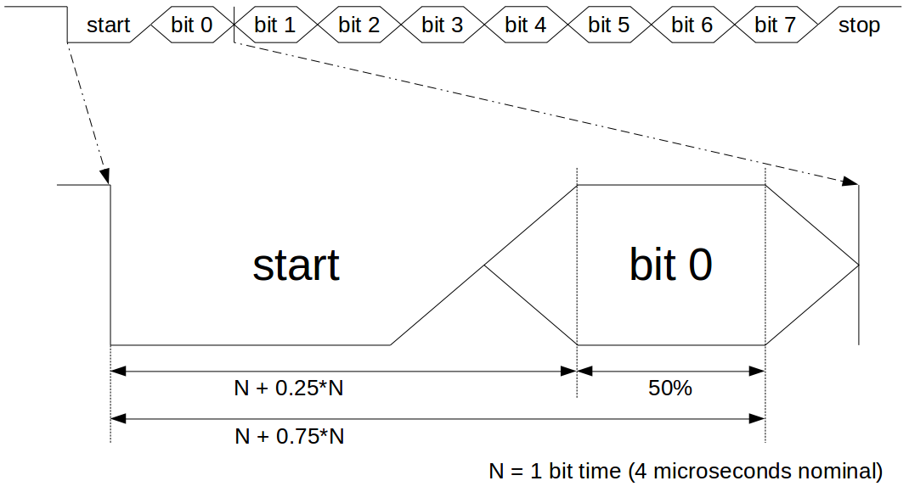  
Figure 1: Bit Timing Sampling Diagram

It is important to understand the operation of a common UART during reception in order to understand why only the middle 50%, of the bit time needs to be valid for a UART to properly decode the data. A UART divides the bit time into multiple sample points and finds the start bit by looking for a falling edge bit transition. Once a falling edge transition is discovered, it counts out one half bit time worth of it sample points, and begins sampling data in the middle of each bit. Some UARTs will use only the middle sample, though many UARTs take the middle three samples with voting to determine the bit value. This technique allows for minor mismatches in bit timing between the transmitter and receiver as well as some bit edge degradation that can occur in transmission lines.

The most common number of UART sample points per bit is 16. The error budget on the midpoint sample is ± 25% (± 50% / 2). That error is equivalent to ±4 clock periods (0.25 * 16). The falling edge of the start bit may not be aligned with the internal UART 16x clock. Therefore, the UART has a built in error of ± 1 clock, which must be subtracted, resulting in an error budget of ± 3 clock periods (4 - 1).

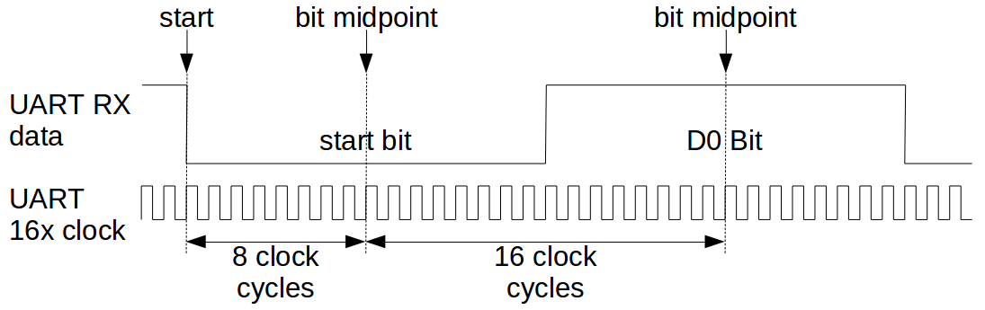  
Figure 2: UART 16x Sample Based Decoding

The worst case timing error will be at the last data sample point, which is the stop bit. The optimal sample point for the center of the stop bit is calculated as:

(16 internal UART clock cycles per bit) * (1 start bit + 8 data bits + ½ stop bit) =

(16) * 9.5 = 152 UART 16x receive clocks after the falling edge of the start bit.

From the allowed UART 16x clock error at the ideal worst case sample point, the combined transmitter/receiver tolerance allowed can be calculated as ± 2% (± 3 / 152). Since the entire ± 2% clock accuracy budget is allocated to the transmitter in the decoder, the detector is expected to have an accurate clock. 100 ppm (0.01%) or better clock references are readily available at a reasonable cost.[1]

The reason to tighten the cutout timing is in order to account for allowable latencies that may occur in the Power Station’s feedback repeater and through the Power Station Interface cable. The worst case latency of a 100Ω characteristic impedance cable is characterized as 5.7 nanoseconds per meter. For a 300 meter cable, the total worst case latency comes out to 1.71 microseconds.

The cable transmission line must be ready to accept transmission at the Start Channel 1 time. A 1000 feet or 300 meter cable (~51Ω DC), terminated at the receiver by 100Ω takes time, after the cutout begins, to clamp the energy left in the cable from before the start of the cutout. Therefore, it is necessary to include some form of active clamping at the receiver before the Start Channel 1 time.

The circuit example in Figure 3 below provides one possible implementation option for receiving the Power Station Interface Feedback.

**Theory of Operation**

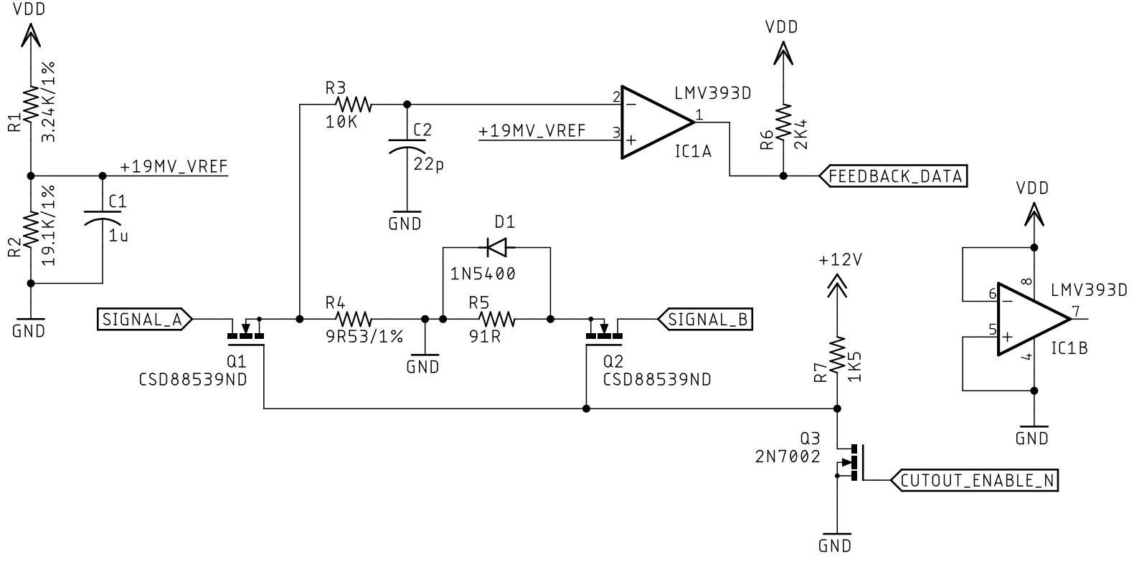  
Figure 3: Power Station Interface Feedback Detector/Receiver Example

During the Cutout, CUTOUT_ENABLE_N is driven low to turn off Q3. This results in Q1 and Q2 turning on by having their gates pulled up to +12V. R4 and R5 combined implement the receiver termination impedance of 100Ω ± 15%. The purpose of D1 is to bypass R5 at the start of the cutout in order to more quickly clamp the energy left in the cable from before the start of the cutout. The current flowing from SIGNAL_A to SIGNAL_B through R4 creates a detection voltage centered around around 2 mA (9.53Ω * 2 mA ~= 19 mV). R3 and C2 work together in order to filter out high frequency noise. FEEDBACK_DATA is the digital feedback data ready to be decoded by a UART. SIGNAL_A is positive polarity Power Station Interface signal and SIGNAL_B is the opposite polarity Power Station Interface signal.

##### Power Station

In this way, the feedback data does not contain any information about a DCC Decoder’s orientation to the track signal.

## Topology

## Labeling

## Trademarks and Acknowledgements

# Future Work

The existence of the feedback techniques represented in this Recommended Practice do not preclude the existence of other feedback techniques. Other techniques may be used which are either proprietary or may be candidates for future adoption.

1. Without rounding, 3/152 is 1.9737%, which is technically less than the allowable 2% in the transmitter, or a combined 2.01% for the transmitter and 100 ppm receiver combined. The 2% tolerance is defined by S-9.3.2, and strictly speaking, it is defined incorrectly. Either the valid bit window would need to be widened to slightly more than the middle 50% of the bit time, or the allowable transmitter tolerance would need to be reduced slightly. It is out of scope of this Recommended Practice to address possible rounding error that is present in S-9.3.2. It is assumed that the rounding error is negligible enough as to be irrelevant in practice. As S-9.3.2 notes, testing on large club layouts, up to a distance of 100 meters, has shown to be problem free.